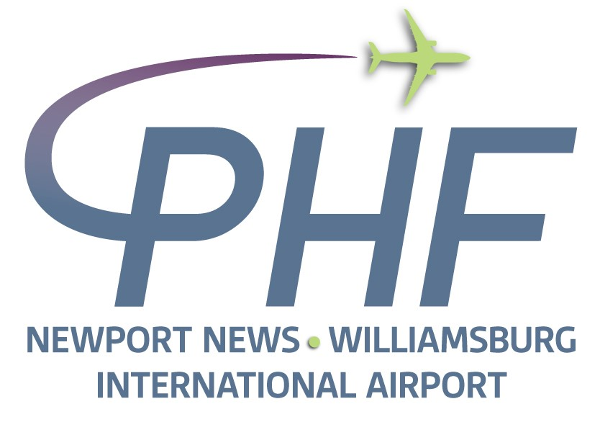

NOTICE OF MEETING
PENINSULA AIRPORT COMMISSION:
GOVERNANCE COMMITTEE

DATE: Monday November 30, 2020
TIME: Immediately following Planning & Development Committee
PLACE: Commission Room,
Newport News / Williamsburg International Airport
900 Bland Blvd, Newport News, VA 23602

